First Baptist Church Varnville
October 5, 2025
Rev. Dr. Thomas Kelly, Jr., Pastor
Mrs. Rebekah Blocker, Minister of Music
Mr. & Mrs. Chip Mixon, Directors of Praise & Worship
Morning Worship –8:30 A.M.

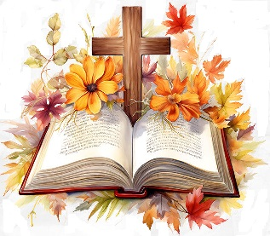

Pre-Call Your Love Never Fails Praise Team

Call to Worship What A Mighty God We Serve Praise Team

Invocation

Welcome & Announcements

Worship Through Music My Savior My God Praise Team

Offertory Prayer

Worship through the Giving of Tithes and Offerings

Janie Chapman Offering Video

Children's Church

Special Music Less Like Me Praise Team

Introduction of Speaker

Message Rev. Jim Brown

Invitation Hymn Awesome In This Place Praise Team

Benediction

Deacon on Call Alex Murray (843-441-7625)
Teller Sheron Barnes

Attendance Last Sunday: Sun. School -73 Early Service -122 11:00 Service -40

Opportunities of the Week:
Sunday: 5:30 Life Recovery Meeting in the Life Center
Tuesday: 7:00am Men's Prayer Group in the Sanctuary
Wednesday: 5:30 Family Night Supper
6:00 AWANA
6:15 Prayer Meeting
7:30 Choir Practice
Thursday: 10:00am Ladies Crafting in Chip's Sunday School Class

Our Finances for 2025-2026: Homebound of the Week
Bdgt. For 2025-2026: $520,082.35 Inez Braxton
Bdgt. Needs for Week: 10,001.58 John Edward Harter Nursing Home
Rcvd. Last Sunday: 6,431.00 Post Office Box 218
Tithe.ly for September: 3,392.80 Fairfax, SC 20927
Bdgt. Needs to Date: 40,006.29
Rcvd. To Date: 30,984.80

VFBC Janie Chapman Offering Goal: $3,500 ∼ Received to Date: $1,225

Playground Equipment Goal: $97,863.00 ∼ Received to Date: $15,642.41

Varnville First Baptist Church is still involved with the Cans for Christ Ministry. Through recycling cans and other metals, Varnville FBC has been able to supplement the purchase of teacher Bibles, football team meals, and other outreach ministries. Please consider donating your aluminum soft drink cans or other recyclable metals to this worthwhile ministry. With football season upon us, monetary donations would be greatly appreciated! Please designate to Tommy’s Projects.


We will have Trunk or Treat on Friday, October 31st from 6-7pm at Varnville First Baptist Church. We are looking for individuals willing to decorate their trunks and hand out candy. We are also accepting candy donations (boxes are in the life center and sanctuary).


In the August 2025 business meeting it was decided to start an organ fund. This is to replace our organ that is no longer working and cannot be replaced. A new organ is going to cost between $65,000 -$70,000. If you would like to contribute to this fund please write organ fund on your donation.

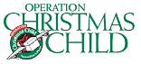
We have been collecting items for the OCC shoeboxes
each month. If you have not donated yet, it is not to late.
We have plenty of boxes if you prefer to pack your own!

WMU
Missions Opportunities
October 2025 - December 2025

October 2025
- Regular Meeting - 10/13/2025
- Pastor Appreciation Sunday - 10/12/2025
- Day of Prayer for A-H Baptist Association-10/19/2025

November 2025
- Regular Meeting - 11/10/2025
- Baptist World Day of Prayer - 11/03/2025
- Prisoner's Packet Due at VFBC - 11/12/2025
- Encourage participation in the Samaritan Purse project, Operation Christmas Child Shoebox
ministry - November 17-21, 2025

December 2025
- Regular Meeting - 12/08/2025
- Lottie Moon Christmas Offering/Season of Prayer
for International Missions - 11/30/2025-12/07/2025

Due to rising prices in groceries, please let us know when you are
unable to come to supper. Please cancel by Tuesday at 12:00 noon.

(Please tear here and place in the offering plate.)
--------------------------------------------------------------------------------------
FAMILY NIGHT MEAL
October 8, 2025
Baked Pork Chops, Rice & Gravy, Baked Beans, Cornbread, Dessert & Tea
$5.00 per Person

Name_____________________________________________________

No. Adults ___________________ No. Children_________________

You can make standing reservations now by calling Sharon at the church office
943-3089, or you can make a weekly reservation by filling out the weekly form
and placing it in the offering plate/box. (Please call by noon on Tuesday if you
are making a reservation or canceling one).

` First Baptist Church

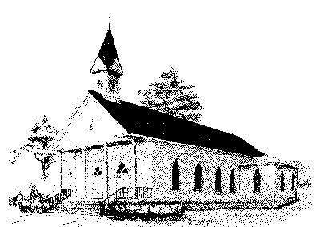

Early Morning Worship 8:30 am
Sunday School 10:00 am
Morning Worship 11:00 am
Wednesday Night Services 6:15 pm

P. O. Box 306- Phone 803-943-3089
165 Palmetto Ave.
Varnville, SC 29944

Website: www.varnvillefbc.com
Email: varnvillefbc@lowcountry.com

Enter to Worship…........Go Forth to Serve

