Opportunities for October

Oct. 2 10:00am Ladies Crafting Group

Oct. 7 7:00am Men's Prayer Group

Oct. 9 10:00am Ladies Crafting Group

Oct. 12 2:00 Deacons Meeting

Oct. 13 Columbus Day

Oct. 13 10:30am Pat Connelly Missions

Oct. 14 7:00am Men's Prayer Group

Oct. 15 6:15 Business/Prayer Meeting

Oct. 16 10:00am Ladies Crafting Group

Oct. 16 6:00 Joy Club Potato Bar
Oct. 20 Newsletter Articles are Due
Oct. 20 6:30 Brotherhood Meeting
Oct. 21 7:00am Men's Prayer Group
Oct. 23 10:00am Ladies Crafting Group
Oct. 23 6:00 Associational Pastor
Appreciation Dinner
Oct. 28 7:00am Men's Prayer Group
Oct. 30 10:00am Ladies Crafting Group
Oct. 31 6:00 Trunk or Treat

Ushers for October
Larry Helms
Hal Horton

Tellers for October
October 6 Sheron Barnes
October 14 Gwen Heape
October 20 Sheron Barnes
October 27 Gwen Heape

Deacons on call for October

Lee Mixson (Sept. 28-Oct. 4)

Alex Murray (October 5-11)

Bill Parker (October 12-18)

Mike Poston (October 19-25)

Randy Vaughn (Oct. 26-Nov. 1)

JOY CLUB

(With all the Fixings)

Thursday, October 16, 2025
6:00 PM in the Social Hall

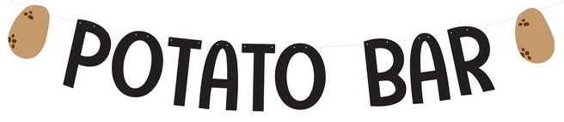

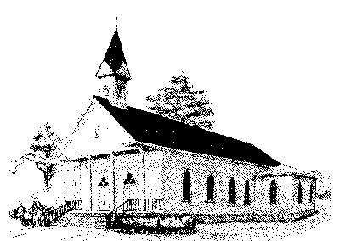
Varnville First Baptist Church, Inc.

Volume 37 Number 10 2025

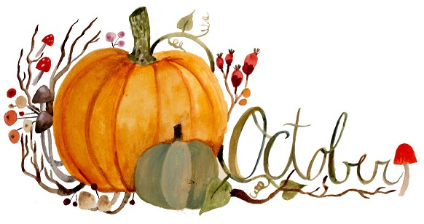

Newsletter



We will have Trunk or Treat
on Friday, October 31st
from 6:00-7:00 P.M.
at Varnville First Baptist Church. We are looking for individuals willing to decorate their trunks
and hand out candy. We are also accepting candy donations (boxes
are in the life center and sanctuary).

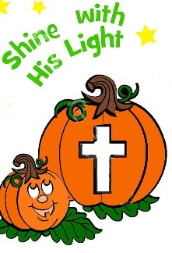


A New Day

Last Sunday, September 28, 2025, Varnville, First Baptist Church voted to entrust a search committee to locate a Minister of Children/Youth. This is an overwhelming task considering the present shortage of ministers throughout all denominations. However, God has a special purpose for our Youth and Children here at Varnville. Within the last year, several have admirably filled in by serving on Children and Youth Committees, Sunday School and Children’s Church.

While these individuals are doing a commendable job, they have other important obligations that need their attention. These people work tirelessly in demanding occupations and continually give their time and talents to God’s calling to minister to children and youth. Yet, they serve in these capacities without any complaints or grievances. The entire church membership is thankful for their service to the Children and Youth.

Although these servants are doing an outstanding job, a vocational minister or devoted couple would add a vital component to the Varnville First Baptist Church family. This position would have a resounding voice to the community that Varnville First Baptist Church loves children and youth. Since many children and youth have difficulty finding love and acceptance, a trusted minister or couple could facilitate much needed support to children and youth. Many adults have testified that a Christian minister helped direct them during a crucial period in their adolescence. Therefore, it is helpful to have someone well-grounded to minister to the church’s children and youth.

However, to find such a competent minister is extremely difficult to locate. Within the Southern Baptist Convention, there is between a fifteen to twenty-five percent shortage of student ministers. Therefore, this should be a consistent prayer concern for all church members. This position could enhance the total ministry of Varnville First Baptist Church.

In Christ,
Tommy

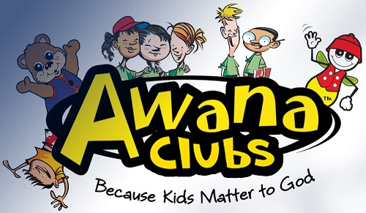

Remember, AWANA has started back up. The AWANA Club meets at 6pm on Wednesday. Bring your children to AWANA and you can join us in Prayer meeting.

Please submit your articles
for the November newsletter to the church office no later
than Monday, October 20th.



Varnville First Baptist Church is still involved with the Cans for Christ Ministry. Through recycling cans and other metals, Varnville FBC has been able to supplement the purchase of teacher Bibles, football team meals, and other outreach ministries. Please consider donating your aluminum soft drink cans or other recyclable metals to this worthwhile ministry. With football season upon us, monetary donations would be greatly appreciated! Please designate to Tommy’s Projects.



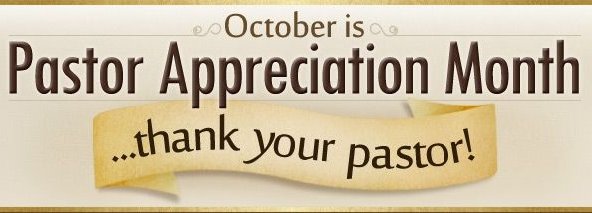



VFBC Brotherhood
Will meet in the Social Hall
Monday, October 20th at 6:30 P.M.

Menu: Low Country Boil





Pat Connelly Missions Group
Will meet in the Social Hall
Monday, October 13th at 10:30 AM

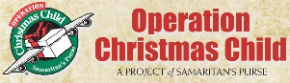

Good News - Great Joy!
We have been collecting items for the OCC shoeboxes each month. If you have not donated yet, it is not to late. By filling these boxes with toys and other fun items, you can be a part of giving boys and girls what may be their first gift ever! Children receive these boxes at festive outreach events where the Gospel is presented in a child-friendly way. We have plenty of boxes if you prefer to pack your own!



October 2 Larry Helms
October 3 Durena Marcum
October 6 Kaye Lovett
October 6 Loretta Smith
October 12 Ann Ayer
October 12 Chris Cook
October 12 Dennis Sawyer
October 13 Kim Noll
October 15 Joan Brown
October 15 Travis Mixson
October 15 Kayla Riner
October 17 Caleb Ayer
October 17 Dallas Mitchell
October 17 Payton Rowell
October 17 Barry Whittington
October 20 Bernadette DeLoach
October 21 Kenny Corbin
October 24 Buddy Douglas
October 24 Evelyn Ginn
October 25 Dylan Mock
October 26 Gerhard Gressman
October 27 Robert Brown
October 27 Wade Ferguson
October 27 Peyton Terry
October 28 Chris Haddock
October 28 Melonee Mattie
October 28 Mary Ulmer
October 29 Danny Crapse
October 29 Jimmy Folk
October 31 Barbara Gray

