First Baptist Church Varnville
November 8, 2026
Mr. & Mrs. Chip Mixon, Directors of Praise & Worship
Morning Worship – 8:30 A.M.

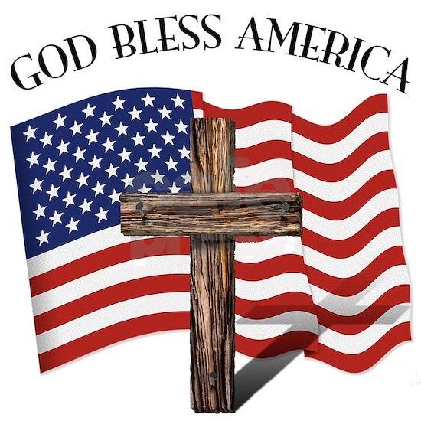

Pre-Call Father Spirit Jesus Praise Team

Call to Worship He Is Exalted Praise Team

Invocation

Welcome & Announcement

Worship Through Music 10,000 Reasons Praise Team

Offertory Prayer


Worship through the Giving of Tithes and Offerings
This month we will focus on games for our shoeboxes. This can be puzzles, jack stones, cards, dominoes, or any game that can fit in our boxes. I appreciate so much all we have collected. I’m excited to see how many quality boxes we pack. I would love to see the little faces when they get their boxes. We pray for these children and pray over the boxes.


Operation Christmas Child Video

Meet and Greet

Special Music Holy Forever Praise Team

Scripture

Message Rev. Jim Brown

Invitation Hymn Turn Your Eyes Upon Jesus Praise Team

Benediction
(Sunday School immediately following this service)

-----------------------------------------------------------------------------------------------------

Deacon Call Lee Mixson (843-812-1215)
Teller Sheron Barnes

Attendance Last Sunday: Sun. School -60 Early Service -85 11:00 Service -40

Opportunities of the Week:
Sunday: 2:00 Deacons Meeting 5:30 Life Recovery Meeting in the Life Center
6:00 OCC Shoebox Packing Party in the Social Hall
Monday: 10:30am Pat Connelly Missions Meeting
Wednesday: Veteran’s Day
Item’s Due for Hispanic Christmas Party 5:00 Choir Practice
6:00 Bible Study/Business Meeting
Thursday: 10:00am Ladies Crafting in Bill's Sunday School Class
2:30 Social Hall Reserved for Garden Club

Our Finances for 2026-2027: ­­­­ Homebound of the Week
Bdgt. For 2026-2027: $506,099.72 JoAnn Williams
Bdgt. Needs for Week: 9,732.69 Post Office Box 211
Rcvd. Last Sunday: 8,185.00 Varnville, SC 29944
Bdgt. Needs to Date: 82,594.21
Rcvd. To Date: 66,237.65
We invite all youth (7th-12th grade) to our brand new Sunday school class led by Joan Brown and Virginia Douglas. The class meets at 10:00am in the youth room. Please come as we grow in faith, connect with friends and explore the Bible. We can't wait to see you there!

WE NEED YOUR HELP! PLEASE!
Annual Pounding for Connie Maxwell Children's Home.
Items Needed:
4lb Bag Sugar----Duke's Mayonnaise----Ketchup----Mustard----Syrup
Women's Body Wash----15 oz. can Sweet Peas----Napkins
Laundry Detergent- Regular or Scent Free----Any Staple items
These items need to be at the church no later than November 18th.

Tuesday, December 1, 2026, will be the Annual Hispanic Christmas Party at Allendale First Baptist Church beginning at 6:00 pm. We need help obtaining new gifts for babies, children, teens and adults. We also need Chips Hawaiian Punch, Hamburger Buns, and Cookies or Cupcakes. These items would need to be here at VFBC no later than Wednesday, November 11th before 2:00 P.M. If you prefer to make a monetary donation then we will shop for you. Thank you in advance for your help.

WE NEED YOUR HELP! PLEASE!
Annual Pounding for Connie Maxwell Children's Home.
Items Needed:
4lb Bag Sugar----Duke's Mayonnaise----Ketchup----Mustard----Syrup
Women's Body Wash----15 oz. can Sweet Peas----Napkins
Laundry Detergent- Regular or Scent Free----Any Staple items
These items need to be at the church no later than November 18th.

Our church has several mission opportunities going on right now. We have OCC Shoeboxes, Connie Maxwell, Hispanic Christmas Party and also the Prisoner Christmas Packets. Please pray and consider helping out with one or two of these projects.

Below is a list of Pulpit Responsibilities for
Varnville First Baptist Church through the month of December.

Date | Early Service | Late Service
1-Nov | Brandon Corley | Brandon Corley
8-Nov | Jim Brown | Jim Brown
15-Nov | Bill Parker | Bill Parker
22-Nov | Aaron Winn | Aaron Winn
29-Nov | Aaron Winn | Aaron Winn
6-Dec | Mike Poston | Mike Poston
13-Dec
20-Dec | Combined Christmas Music Service
27-Dec | Alex Murray |  | Alex Murray
13-Dec | Joseph Douglas | Joseph Douglas
20-Dec | Combined Christmas Music Service
27-Dec | Alex Murray | Alex Murray

We are getting very close to our Packing Party! Remember, I have been hoping AND praying to have 500 boxes. I still need your help.

We need toothbrushes, school supplies and small toys. Just go to Dollar General and find all the $1 toys, socks, jewelry, spring items which are discounted. (No liquid, no glass, no rocks or seeds) You will be surprised at what you can find.

Packing party is Sunday, November 8th at 6:00. Every child will need an adult for assistance. Thanks for your generous donations.
There are several ways to participate.
You can:
-donate items for our packing party
-pack your own box (boxes available at main entrances)
-pack a box online at Operation Christmas Child.org
-make a monetary donation for shipping and handling
-give money to Sharon and have someone shop for you
-PRAY!

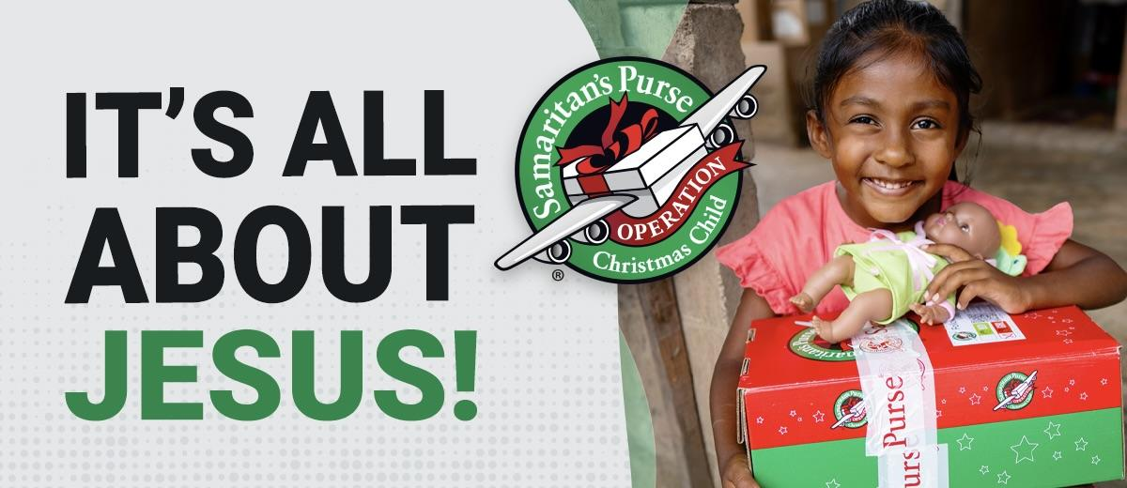

Varnville First Baptist Church will be joining the BridgeBuilders Camp Staff in a unique fellowship activity. Immediately following the 11:00 AM worship service, hamburgers, hot dogs, chips, lemonade, and soft drinks will be served. These lunches will take place July 12th, July 19th and July 26th. Anyone who would like to contribute to this activity, any dessert would be greatly appreciated.

Varnville First Baptist Church will be joining the BridgeBuilders Camp Staff in a unique fellowship activity. Immediately following the 11:00 AM worship service, hamburgers, hot dogs, chips, lemonade, and soft drinks will be served. These lunches will take place July 12th, July 19th and July 26th. Anyone who would like to contribute to this activity, any dessert would be greatly appreciated.

First Baptist Church

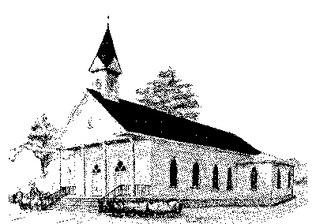

Early Morning Worship 8:30 am
Sunday School 10:00 am
Morning Worship 11:00 am
Wednesday Service 6:00 pm

P. O. Box 306- Phone 803-943-3089
165 Palmetto Ave.
Varnville, SC 29944

Website: www.varnvillefbc.com
Email: varnvillefbc@lowcountry.com

Enter to Worship…........Go Forth to Serve

