First Baptist Church Varnville
August 31, 2025
Rev. Dr. Thomas Kelly, Jr., Pastor
Mrs. Rebekah Blocker, Minister of Music
Mr. & Mrs. Chip Mixon, Directors of Praise & Worship
Morning Worship – 10:00 A.M.



Prelude

Call to Worship “Majesty” Choir and Praise Team

Invocation

The Holy Ordinance of Baptism

Hymn # 101 “How Deep the Father's Love for Us”

Welcome & Announcements

Hymn # 104 “Amazing Grace! How Sweet the Sound”

Offertory Prayer

Doxology

Children's Sermon

Special Music “How Great Thou Art” Eddie Buhler

Scripture (Pew Bible Page 798) Romans 5:1-8

Message “While We Were Yet Sinners” Rev. Dr. Tommy Kelly

Invitation Hymn # 433 “I Surrender All”

Benediction

Deacon on Call Randy Vaughn (864-377-1593)
Ushers for August Bernie Richburg and Douglas Smith
Teller Gwen Heape

Attendance Last Sunday: Sun. School -69 Early Service -93 11:00 Service -39

Opportunities of the Week:
Sunday: 5:30 Life Recovery Meeting in the Life Center
Monday: Labor Day
Tuesday: 7:00am Men's Prayer Group in the Sanctuary
Wednesday: 6:15 Prayer Meeting
7:30 Choir Practice
Thursday: 10:00am Ladies Crafting in Chip's Sunday School Class
The annual church FISH FRY will be Friday, September 12, 2025 in the social hall. Please sign up by September 3rd if you plan to attend. There are sign-up sheets posted in the church and life center.


Our Finances for 2024-2025: Homebound of the Week
Bdgt. For 2024-2025: $510,622.31 Jo Ann Williams
Bdgt. Needs for Week: 9,819.66 Post Office Box 211
Rcvd. Last Sunday: 9,953.00 Varnville, SC 29944
Bdgt. Needs to Date: 500,802.66
Rcvd. To Date: 472,464.29

Playground Equipment Goal: $97,863.00 ∼ Received to Date: $15,227.41


Robert & Joan Brown place the flowers in the worship service today to the glory of God and in honor of their grandchildren, Sara Michela and Allie Guty who celebrate their birthdays this month.

The Christmas Backpacks Ministry seeks to meet the physical and spiritual needs of those living in the Appalachian area and in upstate SC. The backpacks will be distributed to needy children and teenagers during events at which the Gospel will be shared. There is a list of items for this project in the September newsletter. Please purchase a backpack and start filling it with the designated items. Monetary donations are also being accepted. Backpacks are due September 17, 2025

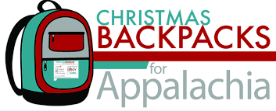


For the month of August we are collecting
SCHOOL SUPPLIES
for the Operation Christmas Child Shoeboxes

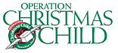

“While We Were Yet Sinners”
Romans 5:1-8

Introduction: Chapter _________ is an ________________ of the ______ word in chapter ________ - ____________________.

No ____________ in the ________ ___________ is more _______________ or more ______________ than this one.

A clear _______________ of Paul’s ____________ is essential if we are to ________ the meaning ____________ by __________.

Keep in ________ that ______________________ is God’s ________________ that I am ____________________ in Christ.

I. Look at ______________________________________ (v. 1-2)

II. Look at the __________ __________ of ___________ (v. 3-5)

III. _____________ might have dealt with __________________ ______________________ in one of ____________ ways (v. 6-8)

\

First Baptist Church

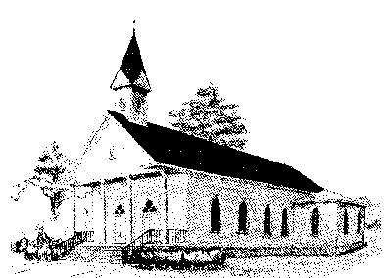

Early Morning Worship 8:30 am
Sunday School 10:00 am
Morning Worship 11:00 am
Wednesday Night Services 6:15 pm

P. O. Box 306- Phone 803-943-3089
165 Palmetto Ave.
Varnville, SC 29944

Website: www.varnvillefbc.org
Email: varnvillefbc@lowcountry.com

Enter to Worship…......Go Forth to Serve

