First Baptist Church Varnville
May 25, 2025
Rev. Dr. Thomas Kelly, Jr., Pastor
Mrs. Annette Tuten, Minister of Music
Mr. & Mrs. Chip Mixon, Directors of Praise & Worship
Morning Worship – 8:30 A.M.
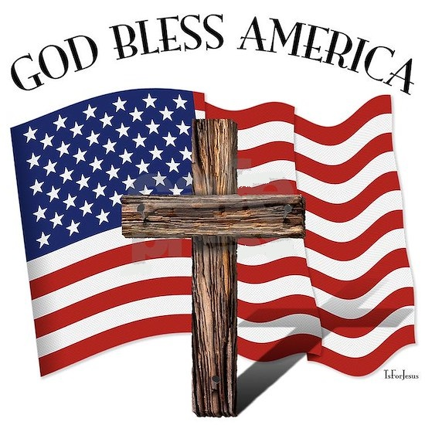

Pre-Call Fields of Grace Praise Team

Call to Worship He Has Made Me Glad Praise Team

Invocation

Welcome & Announcements

Worship Through Music I Could Sing of Your Love Forever Praise Team

Offertory Prayer

Worship through the Giving of Tithes and Offerings

Recognition of Graduate Laney Vaughn

Children's Church

Meet and Greet

Special Music God Bless the USA Praise Team

Scripture John 19:7-18; 20:1-9

Message “The Ultimate Sacrifice” Rev. Dr. Tommy Kelly

Invitation Hymn Above All Praise Team

Benediction

(Sunday School immediately following this service)

Deacon on Call David Ellis (803-942-0481)
Teller Gwen Heape

Attendance Last Sunday: Sun. School -76 Early Service -112 11:00 Service -43

Opportunities of the Week:
Sunday: 5:30 Life Recovery Meeting in the Life Center
Monday: Memorial Day
Wednesday: 6:15 Prayer Meeting
7:30 Choir Practice
Friday: 7:30 Children's Softball Game at Deep Branch
Youth Softball Game will Follow Children's

Our Finances for 2024-2025: Homebound of the Week
Bdgt. For 2024-2025: $510,622.31 Shirley Robinson
Bdgt. Needs for Week: 9,819.66 619 Lightsey Street Ext
Rcvd. Last Sunday: 12,517.00 Hampton, SC 29924
Bdgt. Needs to Date: 374,147.08
Rcvd. To Date: 346,919.18

Playground Equipment Goal: $97,863.00 ∼ Received to Date: $11,747.41

We will continue to take up the Mother's Day Offering through the month of May for the SC Baptist Ministries for the Aging. Received to Date: $685.00

Varnville First Baptist Church is still involved with the Cans for Christ Ministry. Through recycling cans and other metals, Varnville FBC has been able to supplement the purchase of teacher Bibles, football team meals, and other outreach ministries. Please consider donating your aluminum soft drink cans or other recyclable metals to this worthwhile ministry. Monetary donations are also being accepted! Please designate to Tommy’s Projects.

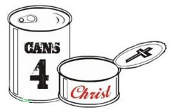

We are collecting for Operation Christmas Child Shoeboxes monthly. Anytime you are out shopping, grab an item or two for our Shoeboxes. Get your children involved too. A collection box is placed in each building. Let's bless as many children as possible. We are focusing on Personal Care Items for the month of May.



Greater love has no one than this: to lay down one’s life for one’s friends. John 15:13


“The Ultimate Sacrifice”
John 19: 7-18; 20:1-9

Introduction: ________________ ____________ started after the _____________ __________.

It was originally named _________________ __________ because the _________ of the ____________ soldiers were ____________.

One _________ ______________ why Memorial Day is celebrated in ____________ is _______________.

________________, _________ ___________ is the ___________ ____________ of the ____________, though some speculate it ________________ __________________.

I. His Sacrificial Death was _______________________ (19: 7-11)

II. His Sacrificial Death was _____________________ (19: 12-18)

III. His Sacrificial Death was ______________________ 20: 1-9)

`First Baptist Church

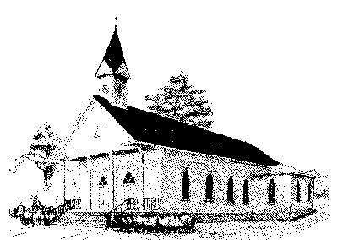

Early Morning Worship 8:30 am
Sunday School 10:00 am
Morning Worship 11:00 am
Wednesday Night Services 6:15 pm

P. O. Box 306- Phone 803-943-3089
165 Palmetto Ave.
Varnville, SC 29944

Website: www.varnvillefbc.com
Email: varnvillefbc@lowcountry.com

Enter to Worship…........Go Forth to Serve

